Invitation to Consider
The United States Military Academy

At West Point, New York

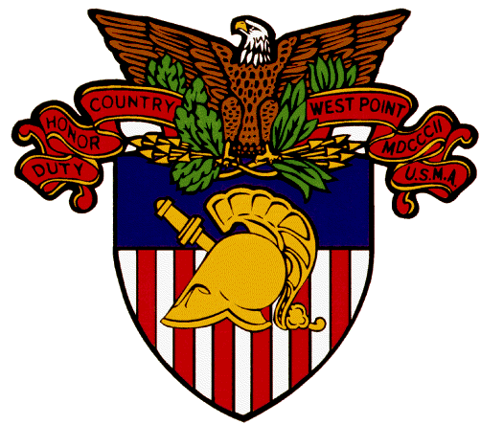

The members of the United States Military Academy Admissions Field Force for Washington State invite you to consider West Point for your post-secondary education. West Point prepares you for a life of leadership and selfless service amid the challenges of ever expanding our nation’s peace and prosperity.

West Point is the world’s premier leader development institution. West Point is a Tier I academic institution and a Division I athletics institution. West Point is our nation’s wellspring of moral and ethical values. West Point is the most broad-minded, open-minded, clean-minded, clear-minded and fair-minded institution in the world. West Point is our national treasure.

We are here to help you learn about and navigate the West Point admissions process. Please use our website:

http://www.west-point.org/academy/malo-wa/

And please also find one of us near you and give us a call:

http://www.west-point.org/academy/malo-wa/fulllist.html

“The Mission of the United States Military Academy is to educate, train, and inspire the Corps of Cadets so that each graduate is a commissioned leader of character committed to the values of Duty, Honor, Country; professional growth throughout a career as an officer in the United States Army; and a lifetime of selfless service to the nation."

