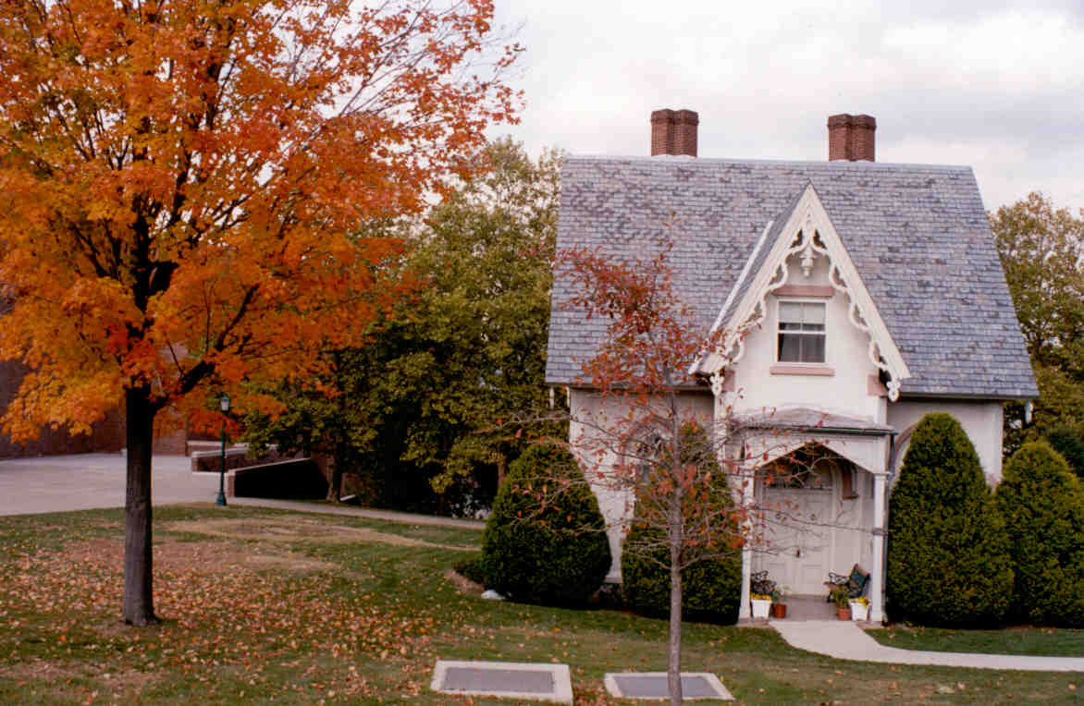
Thomas D. MORGAN (...1816 words)
THE OLD ARMY
The term “Good Old Days” of the Army brings back varying nostalgic memories for old soldiers. For sure, the Old Army was not as it is today. The Old Army has been referred to as a school, athletic club, home for wayward youth, and boys’ camp all rolled into one. Somewhere between the Old Army of the National Defense Act of 1920 and the current one, the reader will find his version of the Old Army.
The Army between the two World Wars is the best-remembered Old Army. It was horse-drawn and very traditional. When mechanization arrived in 1938 and the horses left the stables, it was more traumatic than trading in brown boots for black ones and campaign hats for overseas caps. Massed battalion, marching formations replaced individual squad drill; and the Garand M-1 rifle replaced the legendary Springfield. With the demise of the Old Army went wrap leggings, hand-powered telephones, washpan helmets, and afternoons off for athletics. The mood of the Army changed as the war plans, locked in the orderly room safe, changed from repelling an invasion of Texas from Mexico to defending overseas areas from the threat of global war brought on by Oriental and European enemies.
At the beginning of World War I, some generals had served during the Civil War. Retirement soon forced them off the active lists, but it was difficult for the Army to abandon old customs and adjust to new machines. For example, there is a story about one company commander who did not trust typewriters and required his officers to proofread carbon copies of documents to ensure that they were correct copies. General Carl Spaatz, commander of the Eighth Air Force in England during World War II and first Chief of Staff of the new US Air Force after World War II, was a member of the fledgling Air Service at Fort Sam Houston, Texas after World War I. His future father-in-law was an old cavalry colonel who did not want his daughter going out with young Spaatz because the Air Service was a fly-by-night outfit and Spaatz would never amount to anything.
Long-service regulars were the trademarks of the Old Army as soldiers gathered around the company bulletin board to see who made private first class after only six years’ service. Ordinary privates got $21 per month, privates first class $30, and corporals $42. A second lieutenant started out at $125 per month, one dollar less than a master sergeant. Apparently it was not the pay that kept men in the Old Army.
It was something called “The Outfit” that probably kept men in the Old Army. It was the self-contained company, troop, or battery that took care of the soldiers’ mess, supply, and personnel management. It provided every thing a man needed -- food, clothing, shelter, and security from the civilian world where no one was in charge. This was especially true of the Army during the post World War I and Depression Years in the 1920s and 30s.
First Sergeants were next to God in units. No one spoke to “Top” without permission except the “Old Man.” The “Old Man” was the commanding officer, an experienced captain or first lieutenant, who relied on the First Sergeant to keep things running like a well-oiled machine. Buck sergeants and corporals were barracks’ barons who could “field strip” a deadbeat recruit without breaking stride while walking across a barracks quadrangle. NCOs held their rank only as long as they stayed in the unit that promoted them. For a NCO to transfer with his stripes intact required him to arrange a trade with another NCO of equal rank and specialty in another unit.
General Pershing wanted soldiers who could “shoot and salute.” That was good enough for the Old Army. The Old Army did not do as much as the Army does today, but what it did do was done very well indeed. Enlisted men hardly ever saw an officer because NCOs were perfectly capable of running things. There was no need, as today, to first examine insignia closely before saluting. An officer’s uniform was distinctive. It was usually Class A, never fatigues, with “pink” trousers or riding breeches and boots, and a Sam Browne belt. In the Old Army, it was a pleasure for soldiers to lay a salute on an officer from a hundred yards away.
The Old Army was designed for single men. The system stressed maximum performance of military duty with a minimum of outside distractions. The pay of the lower ranks was not enough to support a family. The Old Army did not enlist married men. Any enlisted man wanting to marry had to obtain permission from his company commander or he could not reenlist. This saved the Old Army a great deal of trouble when it came to solving soldiers’ domestic problems. It also saved the Army money in dependent allowances because few regular soldiers would give up military service for a wife.
Most soldiers lived in the barracks and took their fun where they could find it in bars, dance halls with nice women or women not so nice, or at games of chance as long as their pay lasted. When a soldier’s pay ran out, he stayed on post, went to the movies on credit, played pool in the dayroom, or fired small-caliber weapons on the unit’s indoor range. Some even read books.
When a soldier tired of stateside duty, he could pull a hitch of foreign service in one of the overseas regiments. “See the World” was the Army’s recruiting slogan. These regiments were located in such exotic places as Panama, the Philippines, Puerto Rico, China, Alaska, and Hawaii. Duty with the 15th Infantry in Tientsin, China was specially prized. It had the highest alcoholism and venereal disease rate in the Army, but it always came out on top in inspections. Each year the War Department Inspector General went out to inspect the “Can Do” regiment in China. It finished first because soldiers hired Chinese peasants to do their menial duties. Chinese coolies at a trivial cost per man performed kitchen and stable police. Every soldier had a Chinese striker who cleaned his rifle, shined his boots, polished his brass, and kept his part of the barracks spic and span.
Servants were plentiful in China and the average officer family employed five. Uniforms were tailor-made and Chinese laundries efficiently cleaned them. This led to the term “tailor-made outfit” for the overseas units. All soldiers had to do was pull guard duty, parade for visiting dignitaries, qualify on the rifle range, and draw their pay. In the tropics, bunk fatigue or “siesta” lasted from 1300-1600 each day. Soldiers did not want for varied amusements overseas. Even $21US a month went a long way in China. The lure of the Far East appealed to all ranks. Such famous officers as Generals Stillwell and Marshall did a tour of duty with the 15th Infantry in China.
In Panama, crossing the Isthmus on horseback was considered very adventuresome and a test of soldierly skill. The Army believed it had a tremendous stake in the Caribbean basin as well as in the Pacific Rim. Puerto Rico and Cuba guarded the approaches to the new Panama Canal whose defense was of paramount importance. The Army garrisons in the Philippines were a hedge against further Japanese expansion in the Pacific after the Russo-Japanese War of 1905 and Japan’s takeover of Germany’s Pacific possessions at the beginning of World War I. The Army garrisons in Hawaii were considered a source of great assurance to the security of the American West Coast and trade routes in the Pacific.
Sightseeing tours of the Orient and Latin America for those who could afford them were deemed beneficial for professional education, experience, and information gained. In short, overseas travel in the Old Army was considered broadening and of professional value. Also, overseas stations were generally “wet” meaning that the prohibitions against alcohol consumption of the Volstead Act of Congress (1919-1933) did not apply. Barracks checks and restricting soldiers to garrisons without passes were liberalized a great deal to further enhance the lure of the Far East or Caribbean. Because of the nice, tropical weather overseas, soldiers stationed in the tropics were called “Sunshiners.”
Athletics were king and constituted a large part of the soldiers’ daily program. It could be fairly claimed that World War II was won on the playing fields of army posts between the Great Wars. The quality of athletics was high and competition between individuals and units was keen. Most soldiers played baseball, but football and boxing were also popular. Jogging had not been invented yet. A man out running was probably a boxer, and he was not jogging. He was doing “road work.” Officers played golf, tennis, and polo to improve their hand and eye coordination and to be considered gentlemen. During periods when units were in garrison, athletic activities were scheduled almost every afternoon and off-duty soldiers participated or rooted for their favorites.
Field duty consisted of long road marches at two and one-half miles an hour. That equated to about 15 miles a day. There was little motor traffic on the dusty road around military posts in those days. At night, soldiers pitched two-man pup tents and camped along the roadside. Maneuvers in such places as Texas sometimes were no more than chasing jackrabbits through the cactus and mesquite. In the tropic it meant chasing monkeys through the trees and avoiding jungle reptiles. Field duty acquainted officers and men with tactical operations, field communications, supply procedures, and the experience of hardship living in the open. But, it did not teach soldiers what it was like to face a well-armed and determined enemy. General “Vinegar Joe” Stillwell was known and admired for his ability to walk long distances and live in the Spartan environment of the field. This came in handy when he had to lead his corps’ command group out of Burma back to India on foot after the Japanese defeated his forces in 1942.
The Old Army gave way to the New Army with the Draft, Selective Service Act of 1940. Another big milestone for the Army was when the Draft expired in January 1973 and the Army went back to being a long-service, professional force. Did Old Army practices creep back into the current Army? I will leave that to the reader and his own memories of what the Old Army was really like.

____________________________________________________________
LTC Thomas D. Morgan, Retired, graduated from the US Military Academy at West Point in 1958. He has served as an Artilleryman and in other positions throughout the United States, Germany, Panama, Vietnam, and Belgium. He currently works for a Defense Contractor where he continues to observe the Army at close range.

